Project Design Phase-II
Data Flow Diagram & User Stories

Date | 3 February 2026
Team ID | LTVIP2026TMIDS91648
Project Name | Gemini Historical Artifact Description
Maximum Marks | 4 Marks

Data Flow Diagrams:
A Data Flow Diagram (DFD) is a traditional visual representation of the information flows within a system. A neat and clear DFD can depict the right amount of the system requirement graphically. It shows how data enters and leaves the system, what changes the information, and where data is stored.
DFD Level 0 (Industry Standard)
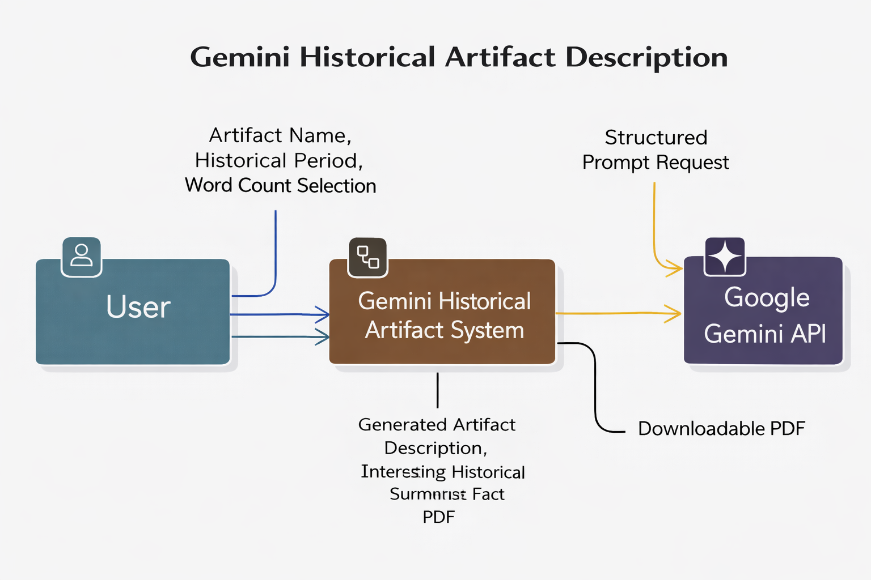
DFD Level 1 (Industry Standard)

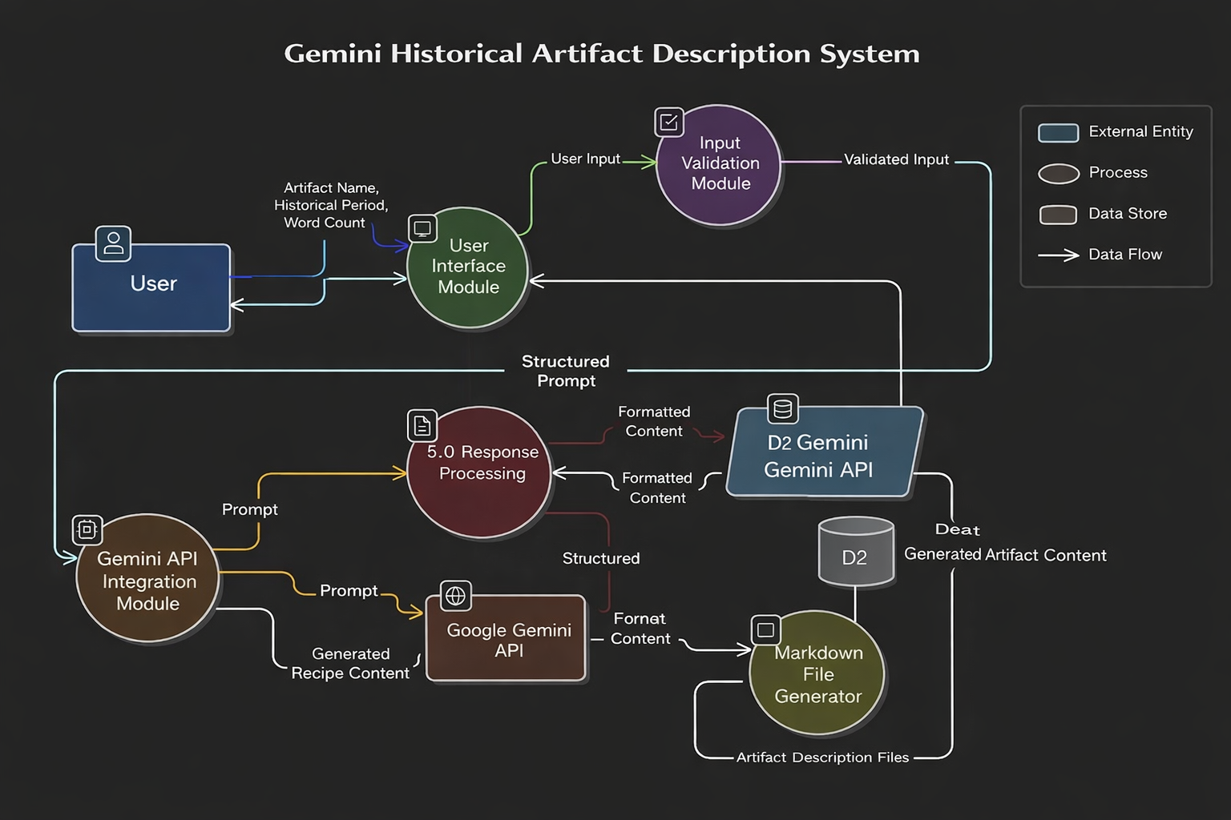

Example:
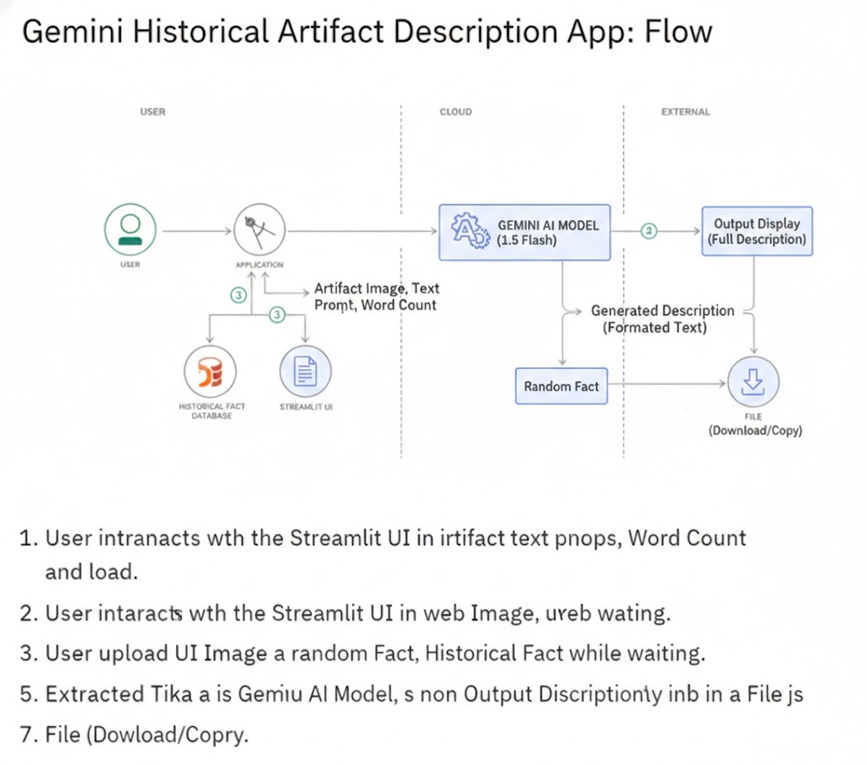
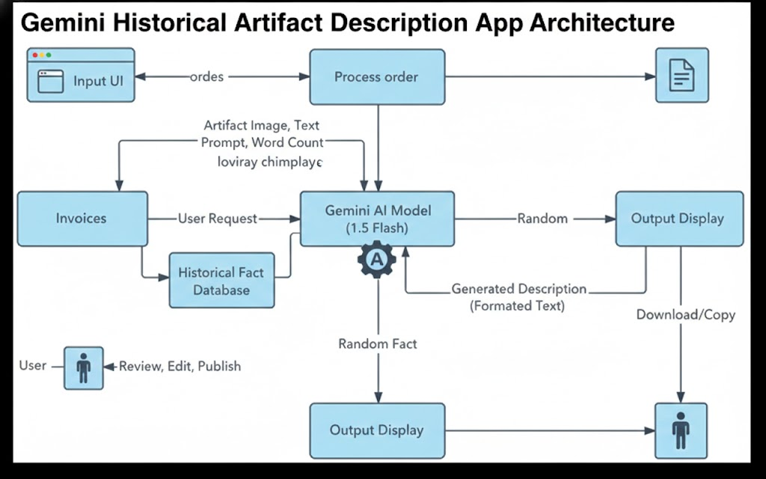

User Stories
Use the below template to list all the user stories for the product.

User Type | Functional  Requirement  (Epic) | User Story Number | User Story / Task | Acceptance Criteria | Priority | Release
Customer (Web  User) | Enter Artifact Name | USN-1 | As a user, I can enter an artifact name so that I can generate its historical description. | System accepts artifact name and displays it correctly before generation. | High | Sprint-1
Customer (Web  User) | Select Word  Count | USN-2 | As a user, I can select desired word count (500–2000 words). | Generated description approximately matches selected word count. | High | Sprint-1
Customer (Web  User) | AI Artifact Generation | USN-3 | As a user, I can generate a structured artifact description using AI. | System generates introduction, historical context, artistic style, and significance. | High | Sprint-1
Customer (Web  User) | Loading Experience | USN-4 | As a user, I can see an interesting historical fact while content is generating. |  | Medium | Sprint-1
  A random historical fact is displayed during loading.
Customer (Web  User) | Display Description | USN-5 | As a user, I can view the generated artifact description on the screen. | Content appears clearly formatted in UI. | High | Sprint-1
Customer (Web  User) | Download PDF | USN-6 | As a user, I can download the generated description as a PDF file. | Clicking download provides valid PDF containing generated content. | High | Sprint-1
Customer (Web  User) | Input Validation | USN-7 | As a user, I am prevented from generating content if artifact field is empty. | System shows validation message and blocks generation. | High | Sprint-1
Customer (Web  User) | Regenerate  Recipe | USN-8 | As a user, I can regenerate description by changing artifact name or word count. | New output replaces previous result without errors. | Medium | Sprint-2
System | Gemini API  Integration | USN-9 | As the system, I must send a structured prompt to Google Gemini API and receive response. | API request succeeds and returns artifact content. | High | Sprint-1
System | Error Handling | USN-10 | As a user, I receive error message if AI generation fails. | System displays clear error message without crashing. | Medium | Sprint-2

